Bayleigh Kelton assignment 2.2

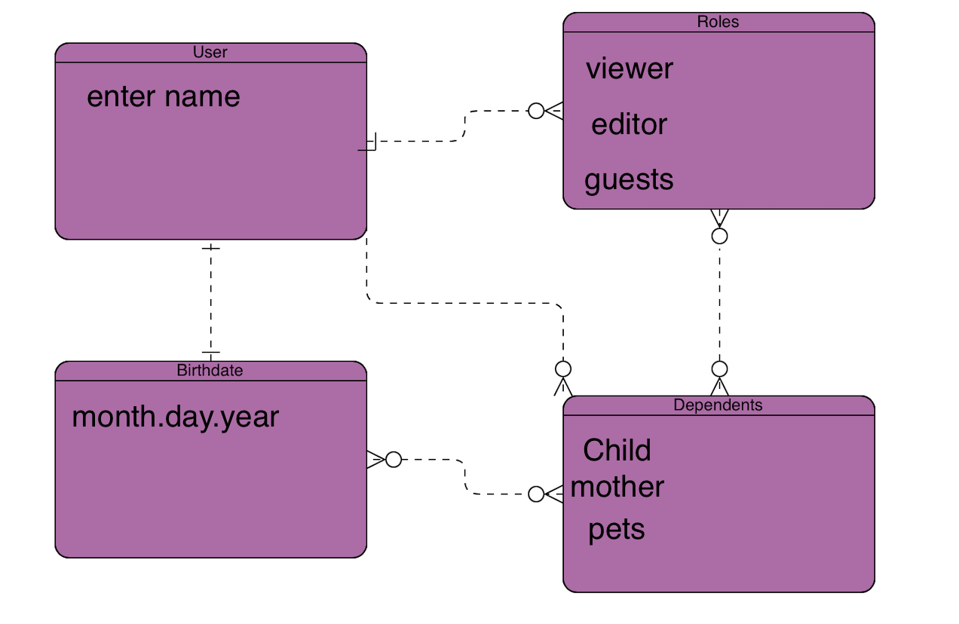

NoSLQ Data Structure:

{

“first_name”: “bayleigh”

“Last_name”: “Kelton”,

{

“birthdate”: “10.04.2000

},

{

“roles”; [“moderator”, “viewer”],

},

{

“Dependents”; [“{mother”; ”selena”, “child”;”sam”}]

}